This article is in continuation with Part 1. In Part 1 we have seen how to create a chart.
In this article we will explore categories, values and series option.
Category: Category is used to display the information on the X-Axis of the Chart.
Values: Values are used to display information on the Y-Axis of the Chart which is mostly numeric values.
Series: Series are used to display multiple charts for each category groups.
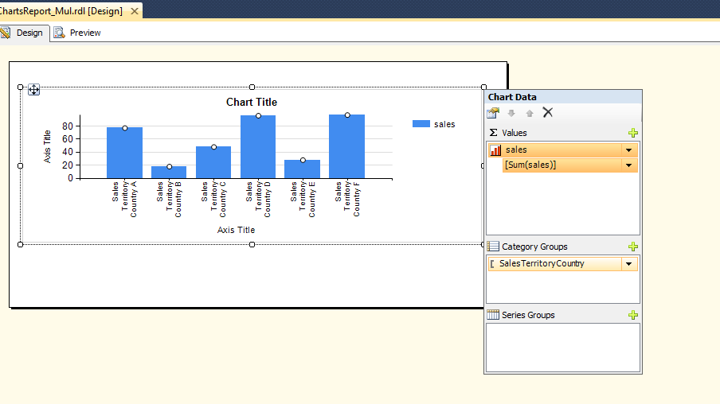
In the Report we have chosen a single category and single value.
Now we will see how to display multiple categories.
To select another category go to category group and add another category group.
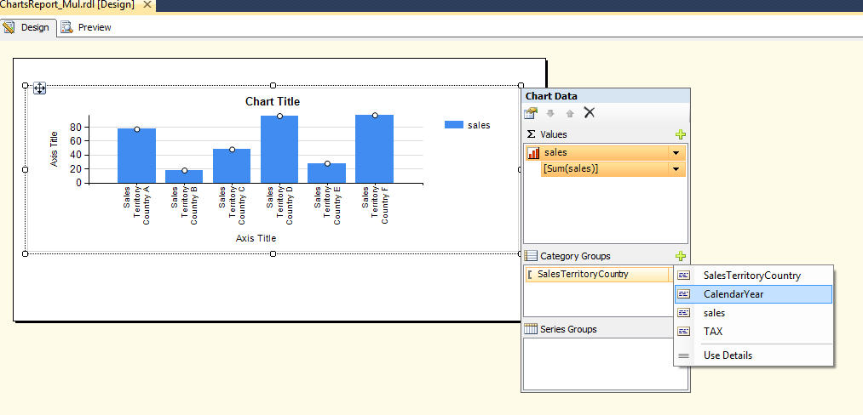
So I have selected Calendar Year from the category group.
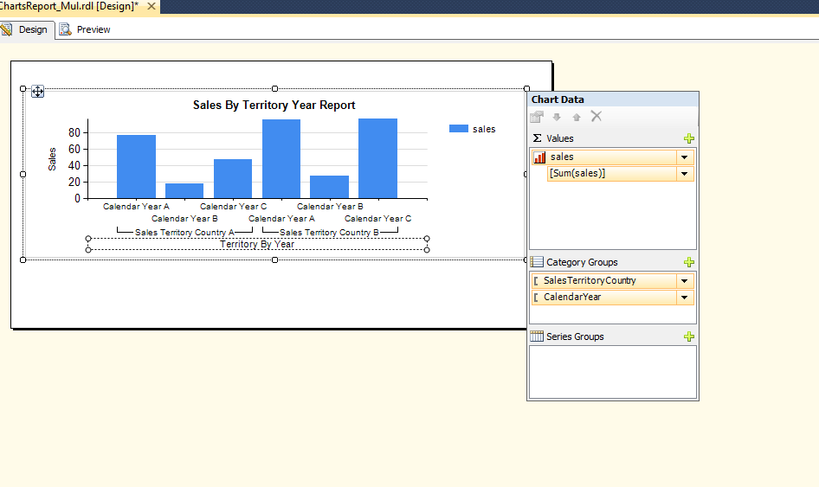
The Report now looks like this.
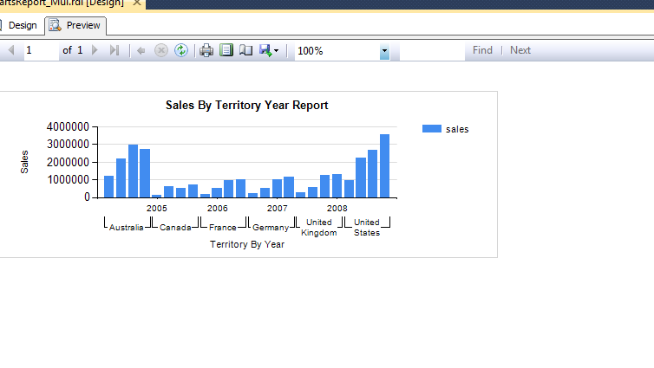
This will display the sales for each territory for each year. Now if you look it is not displaying all the years for particular Territory.
We have to change the horizontal axis properties to display each of the years.
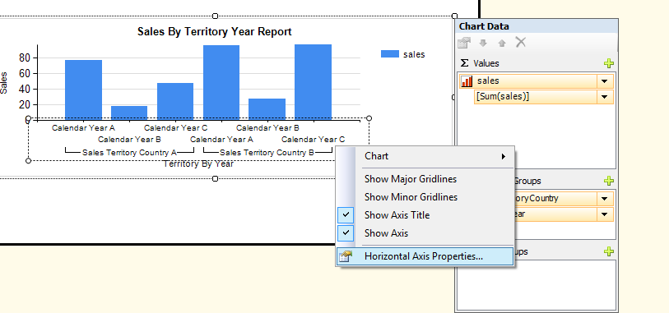
Right click on Horizontal Axis and go to Horizontal Axis Properties.
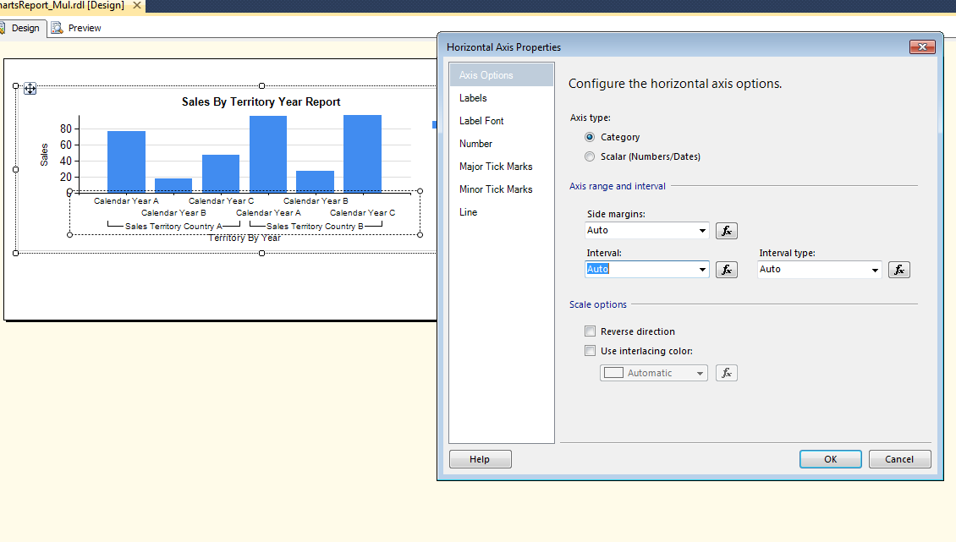
In the Horizontal Axis Properties select the Interval as “1”.
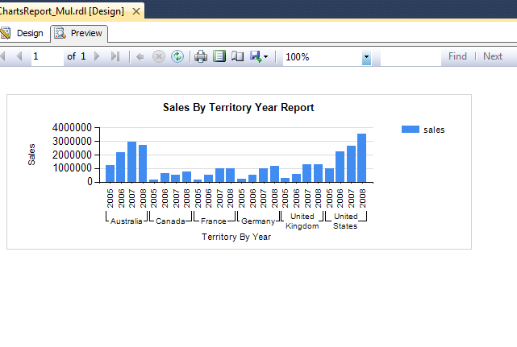

Adding multiple values in the Chart Data.
Similar to adding new category we can add new values to the Report.
To add a new value, select Chart Data and Add a New Value in the section.
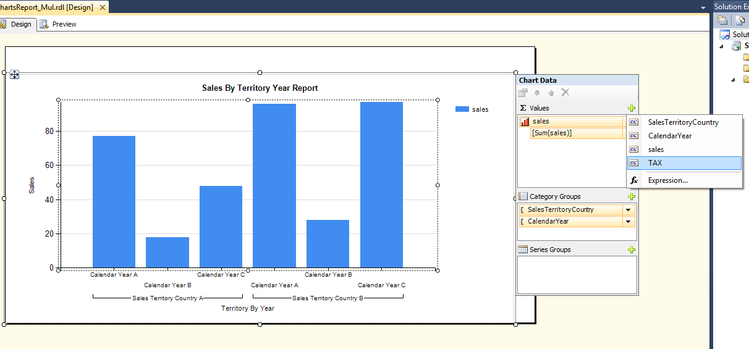
After selecting Tax in the ChartData-Value section. The report will look like this. It will create a New Bar for Tax in the Report.
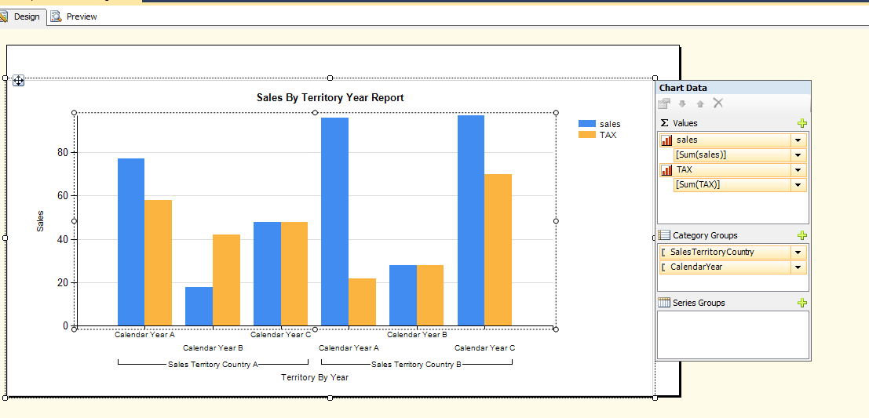

The Report Preview will be seen like this.

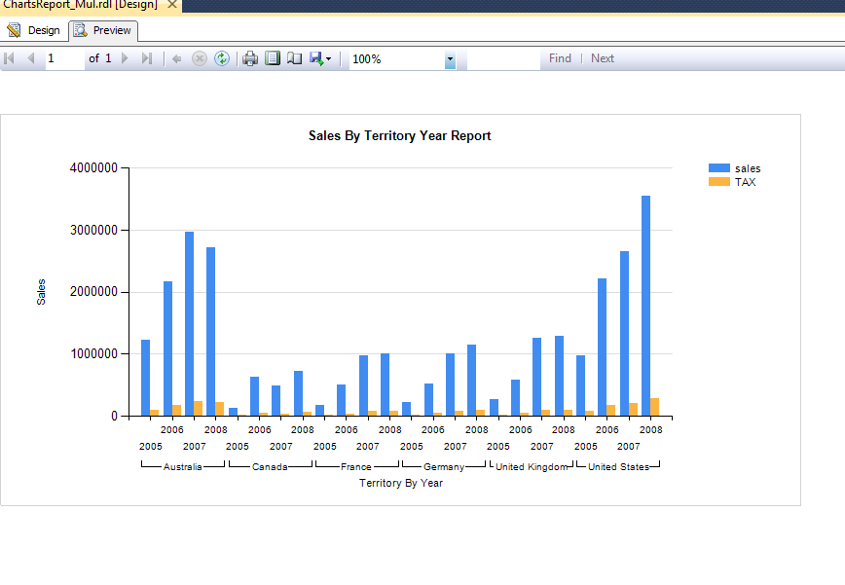
Changing the Axis of the Report. Now if we look at the Report, the Tax is showing the in the same axis as of Sales.
If we want, we can change the axis of Chart to the right side.For that Right click of the Tax Value as shown below.
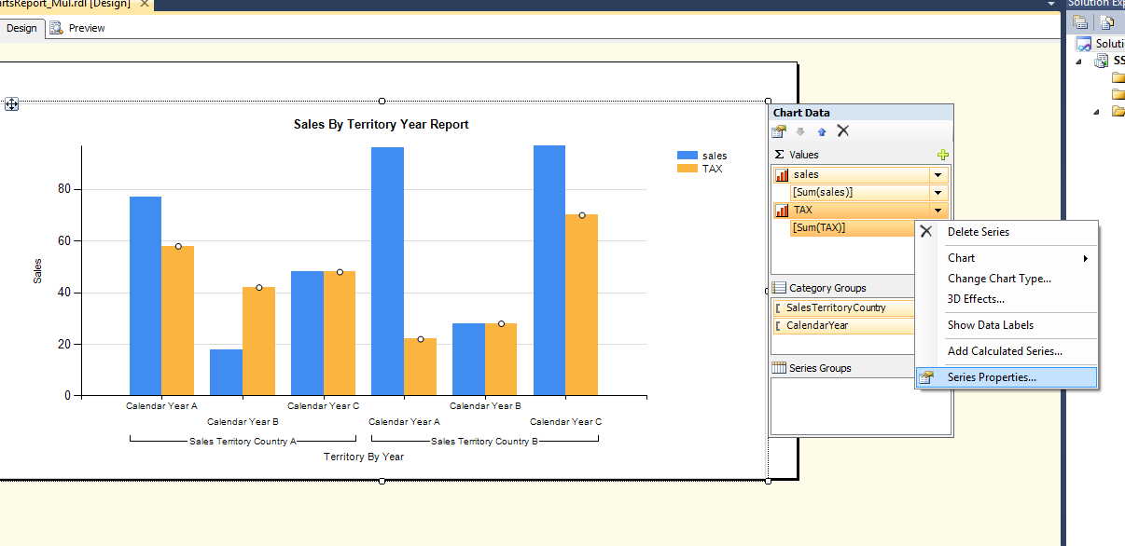
In the series properties, go to Axes and Chart Area and select vertical axis as “Secondary”
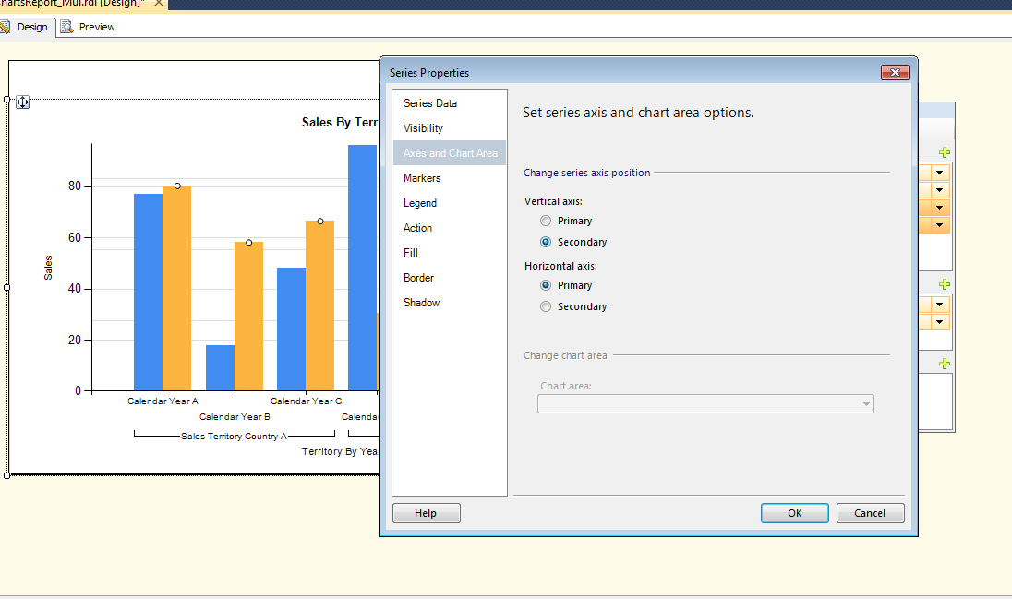
Now the chart will appear like this.
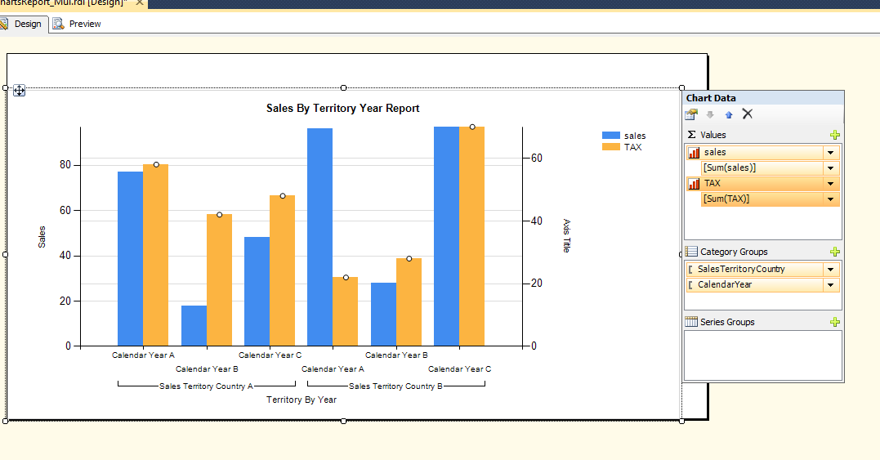
The Preview of the Report will look like this.
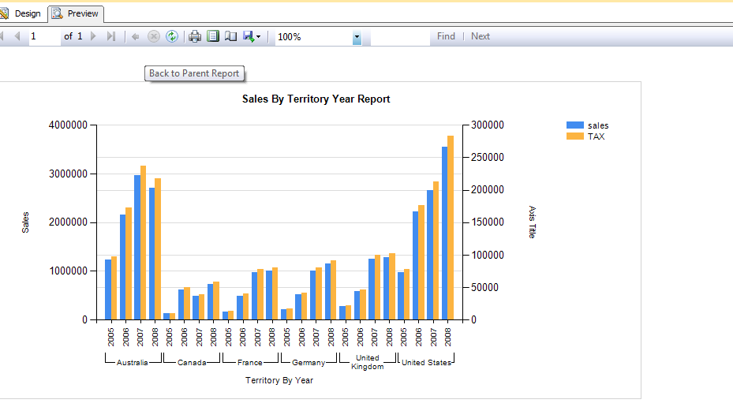
Adding Series Groups to the Report.
First of all, we will remove the Category Group “Year” from the Series.
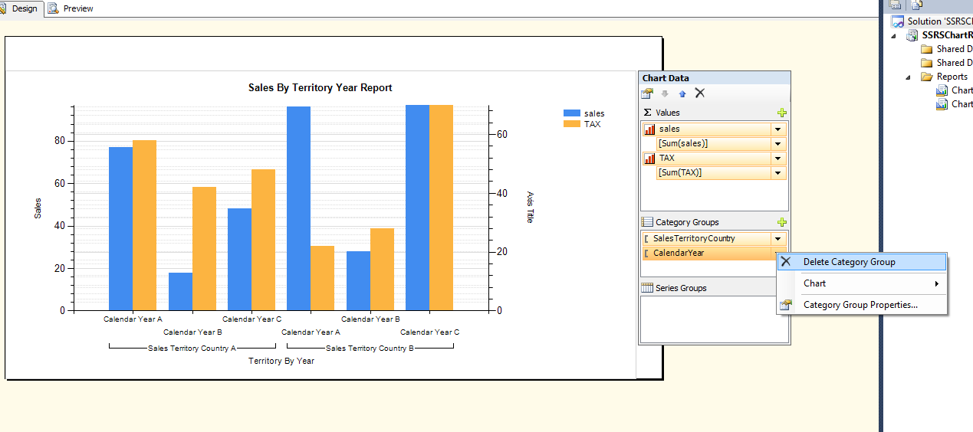
Then we will go Series Group and add “Calendar Year”.
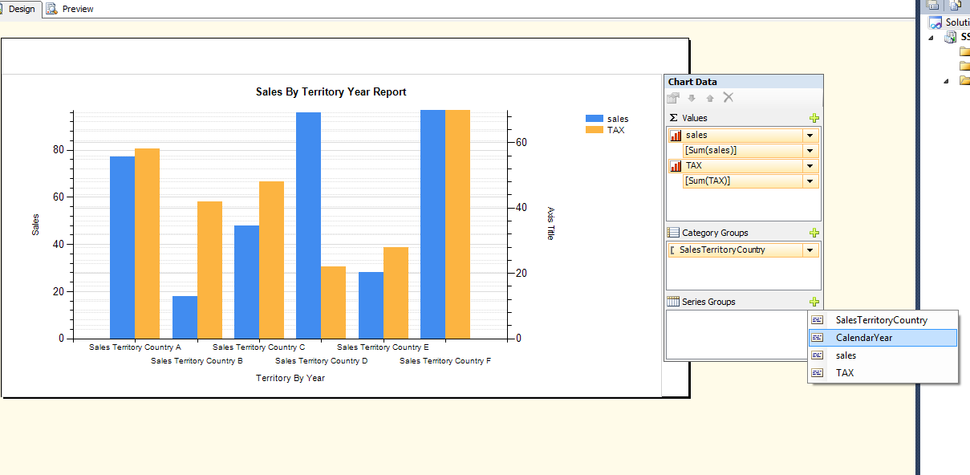
The Report will look like this.
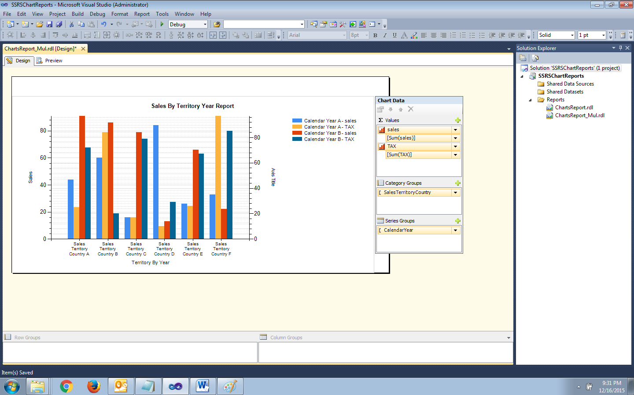

The Preview of the Report will be like this. It will display multiple bars for each category.
