In this Article, I will explain you how to prepare a Bar Chart. Also we will discuss the concept of category, values & series.
The database which I will be using for this example is AdventureWorksDW2008R2.
The query which I will using for this example is as follow
SELECT s.SalesTerritoryCountry,d.CalendarYear,
sum(f.SalesAmount) as sales ,SUM(F.TaxAmt) AS TAX FROM FactInternetSales f
inner join dimdate d on f.DueDateKey = d.DateKey
inner join DimSalesTerritory s on f.SalesTerritoryKey = s.SalesTerritoryKey
group by s.SalesTerritoryCountry,d.CalendarYear

To Create a Chart Report the steps we will be using are as follow
- Create a SSRS Report
- Add a RDL report file.
- Create a Data Source
- Add a Dataset and execute the SQL Query to return the fields as follow
    - SalesTerritoryCountry
    - CalendarYear
    - Sales
    - Tax
- Insert Chart into the RDL file and select the Chart Type as Column
- Once the chart is being selected go to the Chart Data Properties by double clicking the chart
- In Chart Data Properties, In the Category Groups add the “SalesTerritoryCountry” field.
- In Chart Data Properties, In the Values add the “sales” field.
- Preview the Report

Step 1 : Create a SSRS Report
Go to Microsoft SQL Server 2012 from Program Files, and select SQL Server Data Tools
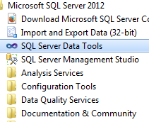
Start SQL Server Data Tools and select File : New Project
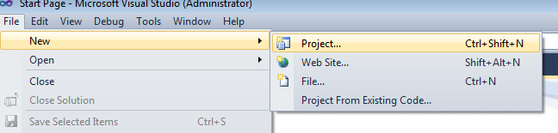
Select Reporting Services : Report Server Project
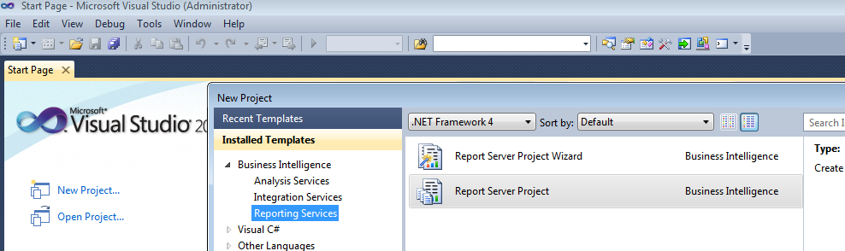

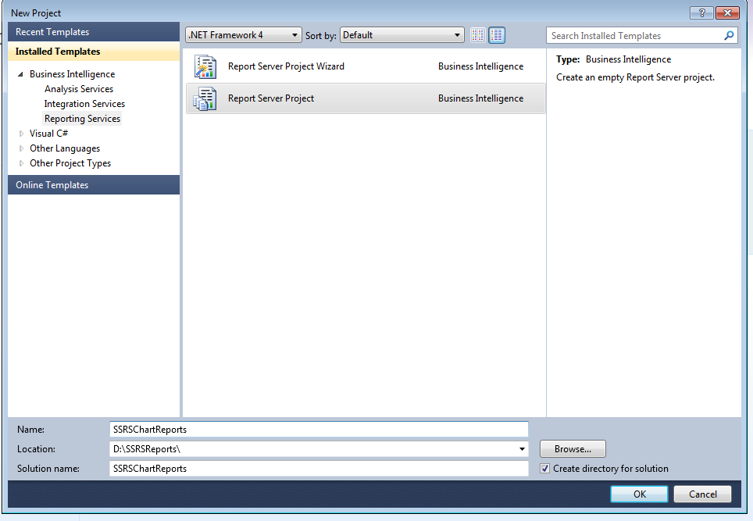
Give The Project Name as “SSRSChartReports” and select “OK” button.

Step 2 : Add a RDL File

Go To the Solution Explorer and select Reports -> Add New Item

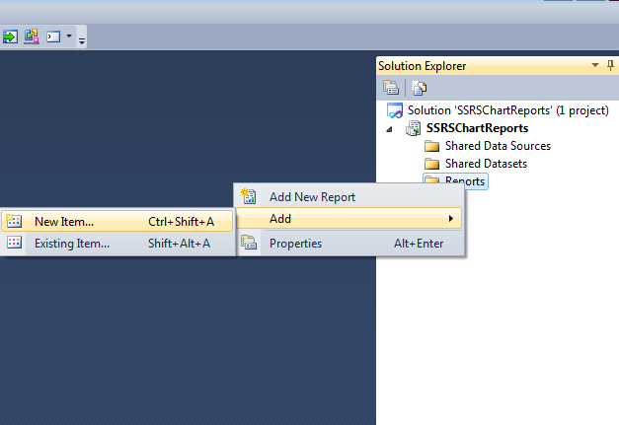

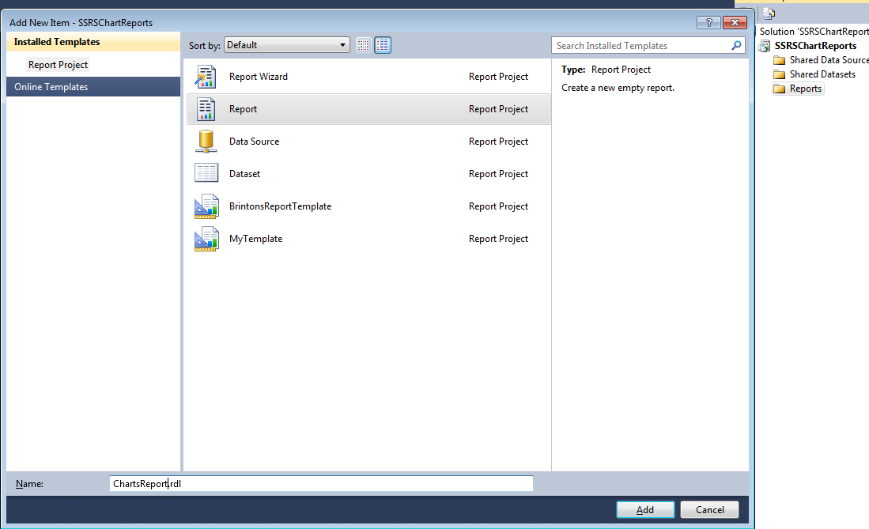

Step 3 : Add a Data Source

Go to Report Data section and Right Click on the Data source and Add Data Source
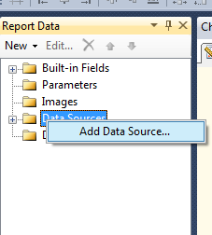
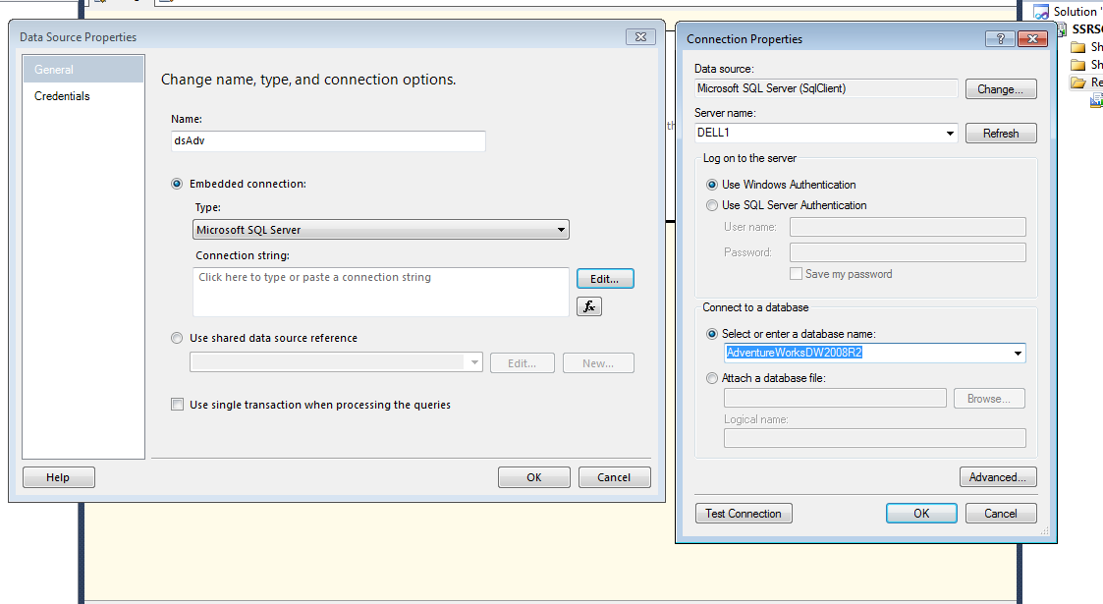

Step 4 : Add a Data Set
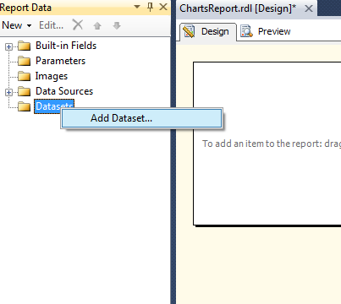

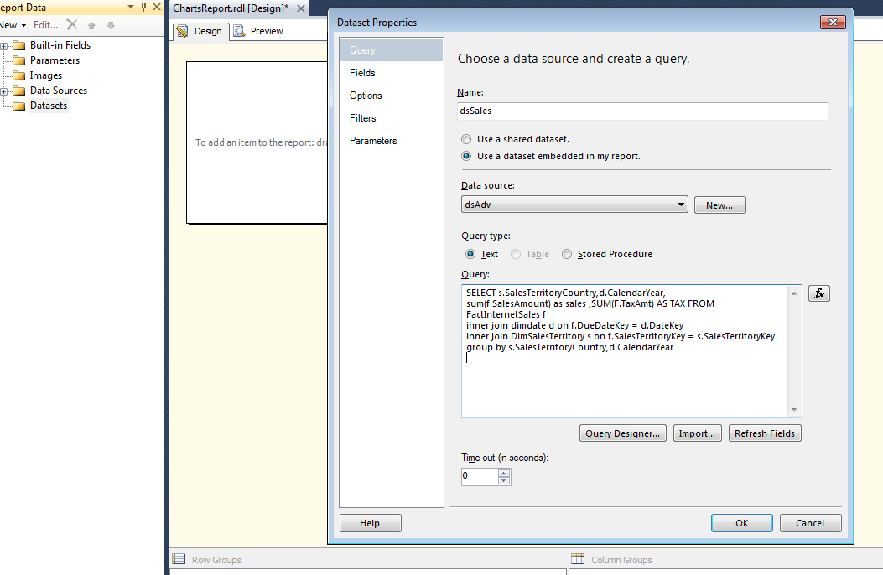
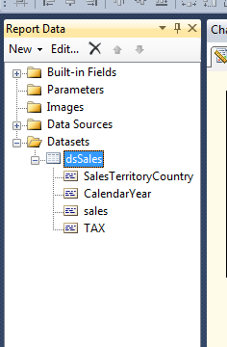

Step 5 : Insert a Chart Into the Report
Right click on Report Designer and Insert -> Chart
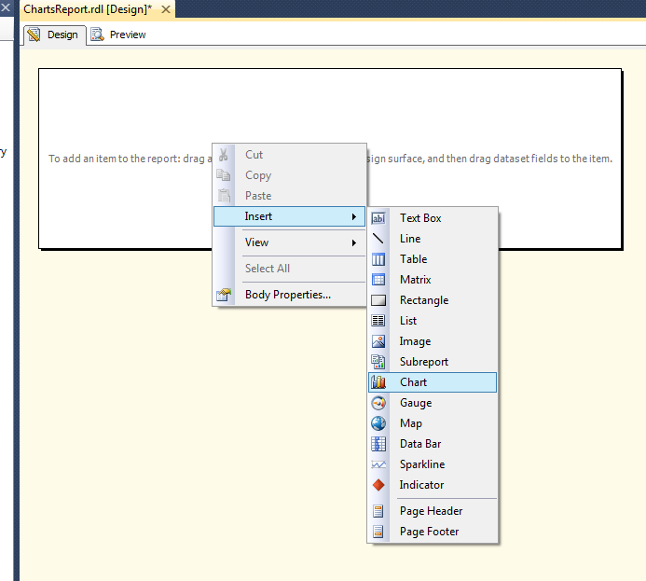

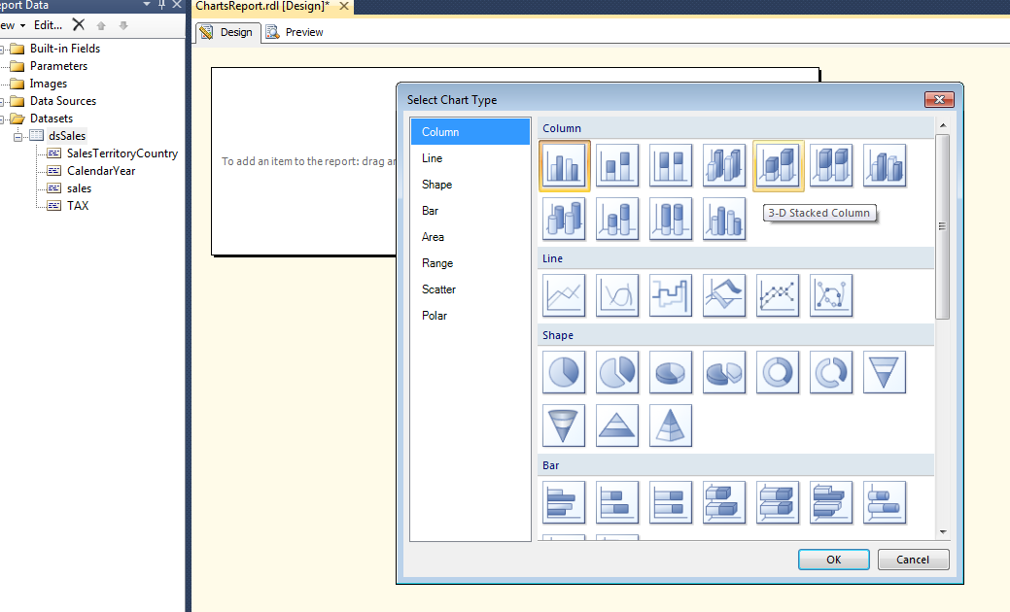

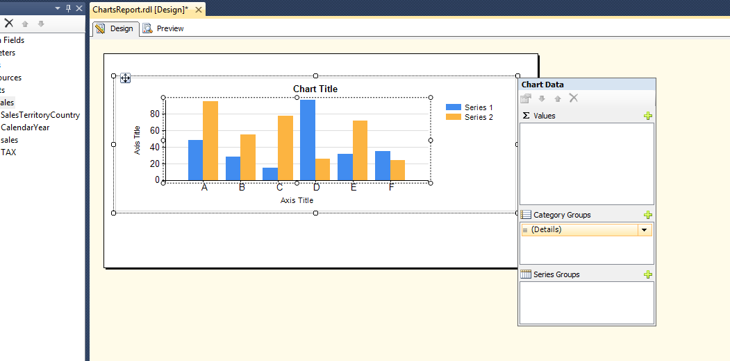

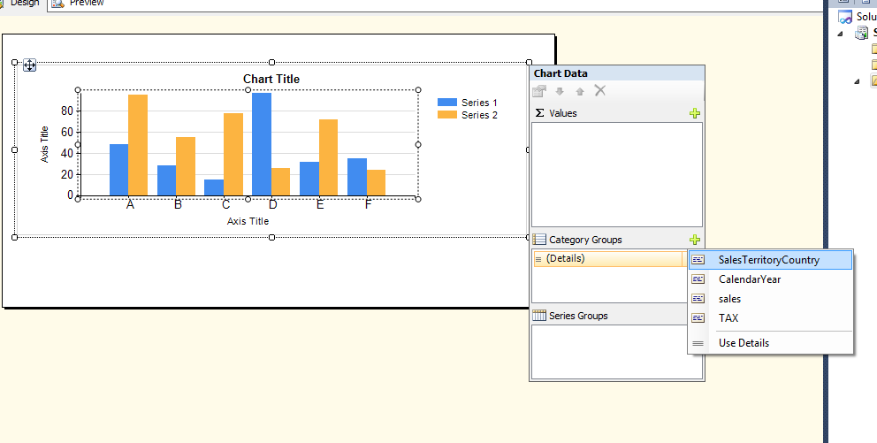

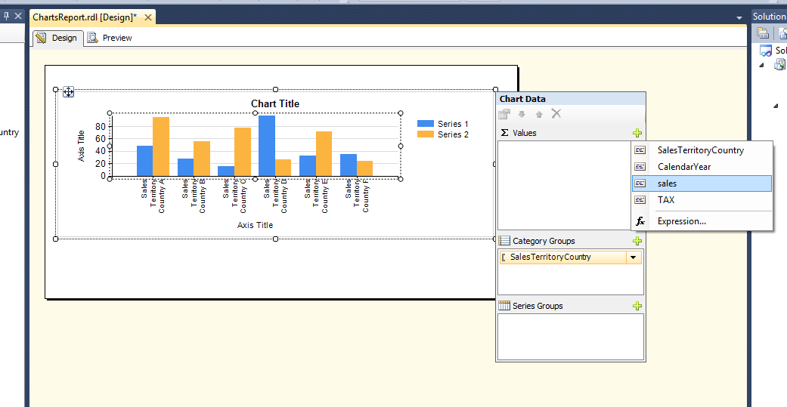

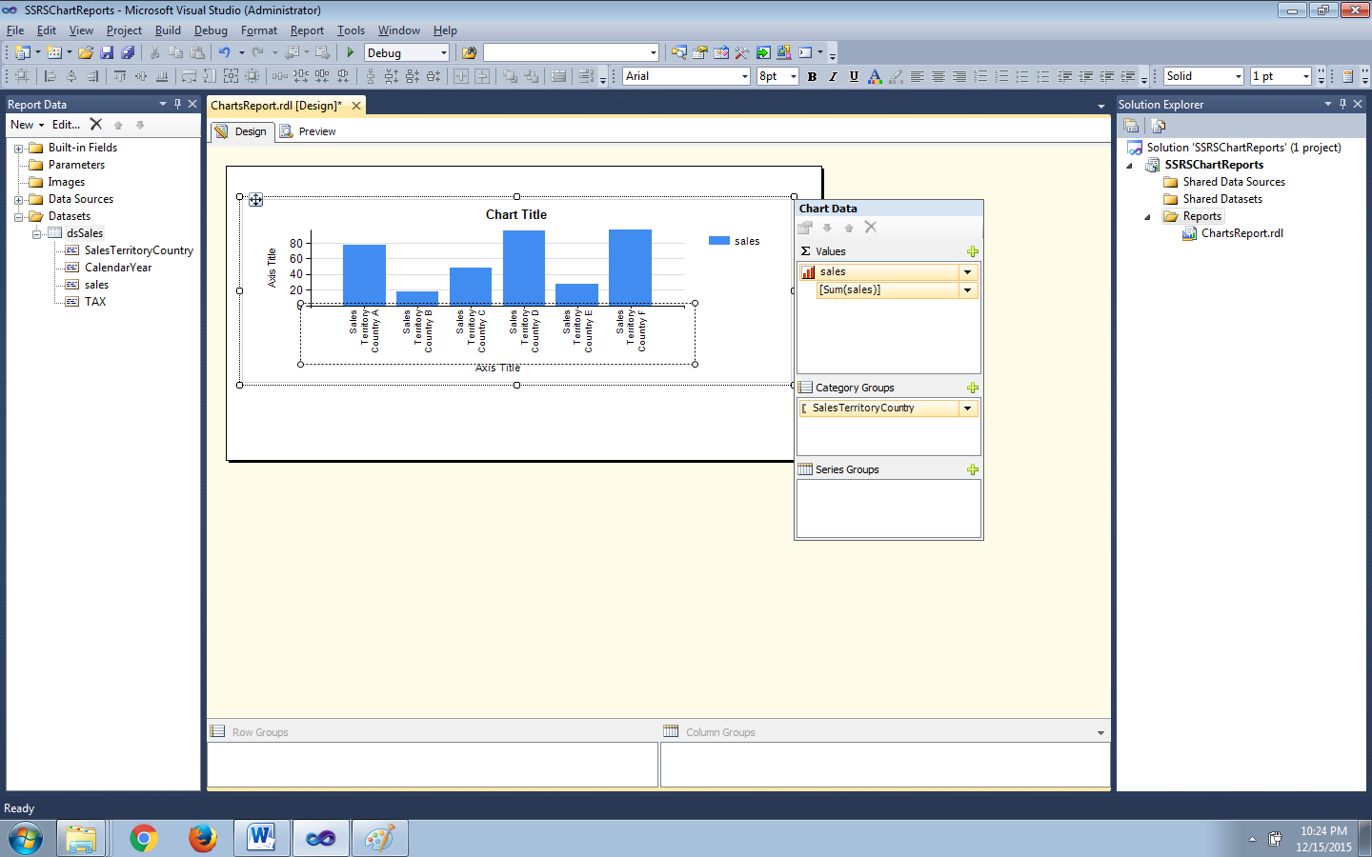

Preview the Report
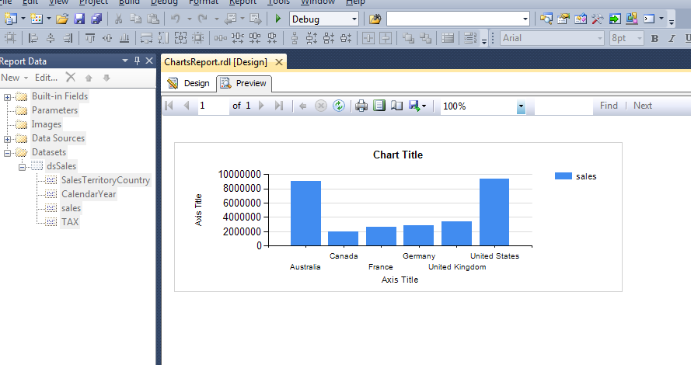
Now the Titles of the Reports are simple TextBoxes which can be changed as required.
Report after changing the Titles.
