SSAS ASSIGNMENTS [Using AdventureWorksDW database]
Create a Cube using the following Measures & Dimensions.
Measures :FactInternetSales, FactResellerSales
Dimensions :DimSalesTerritory,DimDate,DimCustomer,DimProduct,DimReseller
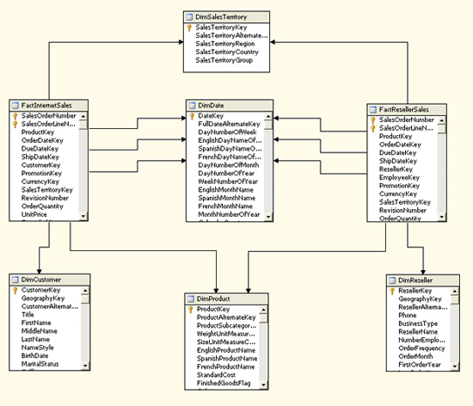
Define the Calculated Member Profit
([Measures].[Sales Amount] - ([Measures].[Total Product Cost] + [Measures].[Tax Amt] +
[Measures].[Freight]))

