ASP CHARTING CONTROL

ASP.NET provides Charting control to create simple and visually compelling charts which can be used to show different statistics or financial analysis.
This article will introduce you to the basics of the asp charting control and will cover all the basic information so that you can generate the charts using ASP.NET charting Control.
The Charting control is present under Toolbox -> Data -> Chart, you can simply drag the control and drop it to the asp form.
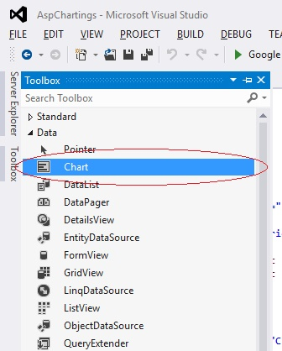
The asp:Chart control will add certain code to the file mentioned below :
<asp:ChartID="Chart1"runat="server">

</asp:Chart>
You can give meaning full ID to it for example if you are implementing Employee gender ratio you can use id like ID="gender_ratio".
asp:Chart contains two tags :
- <ChartAreas>
- <Series>

<ChartAreas>:
it deals with the number of area the chart has for example .
<ChartAreas>

<asp:ChartAreaName="ChartArea1"></asp:ChartArea>

<asp:ChartAreaName="ChartArea2"></asp:ChartArea>

</ChartAreas>

In this Example the total area of chart will divide into two parts.You can declare as many Chart area you want.

<Series>:
it deals with the implementation of the chart area we have declared in the <ChartAreas>
tag , i.e <Series> each tag has a specific area to display its attributes for example.
<Series>
<asp:SeriesName="Series1"ChartArea="ChartArea1"ChartType="BoxPlot">
<Points>
<asp:DataPointLabel="male"YValues="20"/>
<asp:DataPointLabel="female"YValues="80"/>
</Points>
</asp:Series>

<asp:SeriesName="Series2"ChartArea="ChartArea2"ChartType="BoxPlot">
<Points>
<asp:DataPointLabel="male"YValues="40"/>
<asp:DataPointLabel="female"YValues="60"/>
</Points>
</asp:Series>

</Series>

If we use all the tags discussed above the code will be seen like this:

<asp:ChartID="GenderRatio"runat="server">
<Series>
<asp:SeriesName="Series1"ChartArea="ChartArea1"ChartType="pie">
<Points>
<asp:DataPointLabel="male"YValues="20"/>
<asp:DataPointLabel="female"YValues="80"/>
</Points>
</asp:Series>

<asp:SeriesName="Series2"ChartArea="ChartArea2"ChartType="bar">
<Points>
<asp:DataPointLabel="male"YValues="40"/>
<asp:DataPointLabel="female"YValues="60"/>
</Points>
</asp:Series>
</Series>

<ChartAreas>
<asp:ChartAreaName="ChartArea1"></asp:ChartArea>
<asp:ChartAreaName="ChartArea2"></asp:ChartArea>

</ChartAreas>

</asp:Chart>

Output of this Code will be like this :
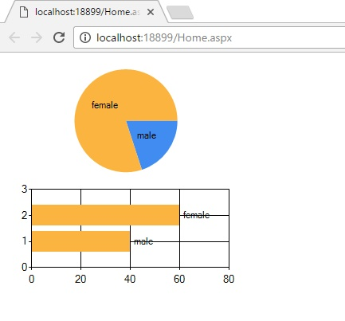

We will cover the Advance concepts like 3D charts and Dynamic Charts in Next article.

