JMeter Download and Installation Guide

Before you download and install JMeter, your should ensure that your computer meets the basic requirements for its installation. JMeter runs on most operating systems however its good to check if your operating system is supported to avoid any issues.

1.Java Virtual Machine
JMeter is developed in the Java programming language. Therefore, it requires a fully compliant JVM 6 or higher.

2.Operating System
JMeter can run on any operating system which is supported by Java.
The latest version of JMeter works well in Linux, Solaris, OS X and Windows. If your computer uses above OS, you should be able to get JMeter running using the steps below.
This topic will guide you how to install and launch JMeter in Window 7, Java SDK 8.x but the steps are similar on all operating systems.

3.Getting Started
The following figure describes the steps required to install and launch JMeter.
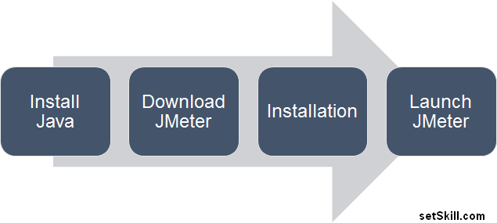

Step 1. Java Installation
If you do not have Java installed on your machine, you can download the Java runtime from http://java.com. Click on the Free Java Download button on the homepage as shown below.

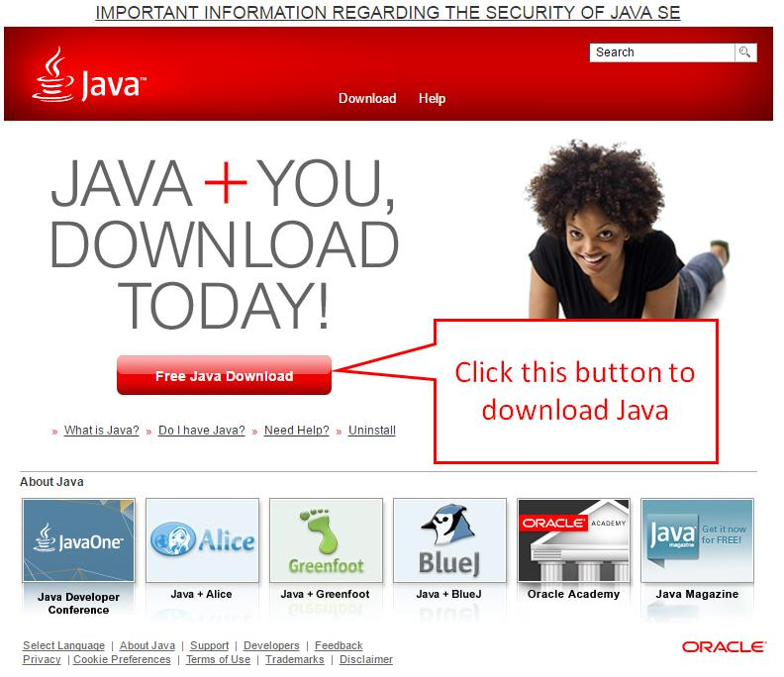

This will open the Java download page. You may see a warning message if your browser does not support Java in a standard manner. However you can ignore this and click on the Agree and Start Free Download button.
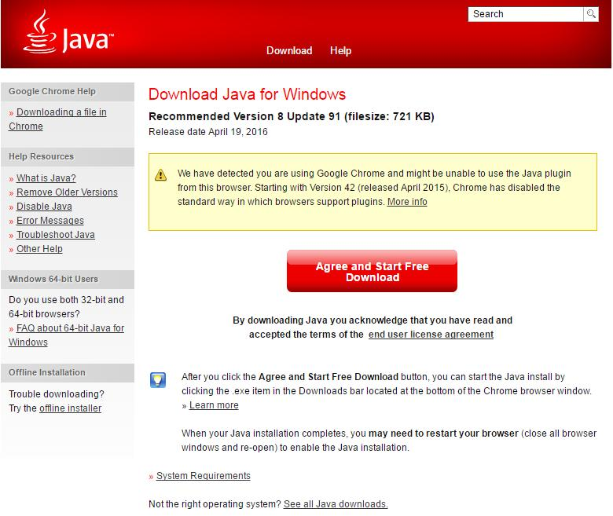
You will be prompted to save the downloaded file. Save the file to your preferred location on your computer. After the file is completely downloaded, you need to run the file and follow the instructions given by the installer to install Java.
After downloading and installing Java, you can verify whether Java is installed succesfully in your operating system.
Open Start > Run > Type the command CMD to launch the command prompt and enter: java –version.
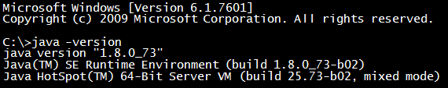
If Java is installed, you will see the version information of Java displayed as shown above. You can now proceed to Step 2.

Step 2. Download JMeter
The latest version of JMeter at present is 2.13. You can download JMeter from the link below
http://jmeter.apache.org/download_jmeter.cgi
Apache offer you 2 options when downloading JMeter. You can choose either binary files or source code.
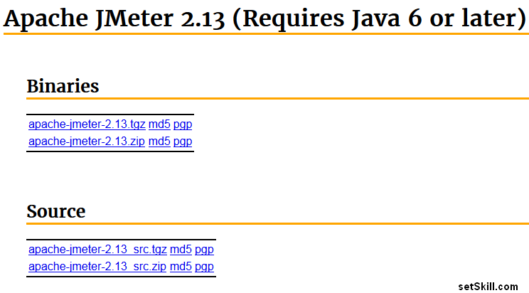
If you are a developer and you want to customize the JMeter source code, you can download the package listed under Source. You can use this to build JMeter on your machine and customize it as per your requirements.
In this tutorial, we will download the binary version of JMeter listed under Binaries. Click on the apache-jmeter-2.13.zip file to download the zip file.

Step 3. JMeter Installation
After you download and extract the zip file, you can browse the JMeter directory. It contains the folder structure as shown in the image below.

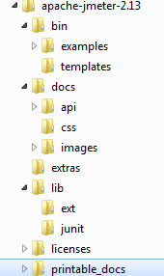

Details of the folders are given in the table below.
Directory | Description
\bin | JMeter binary files (for launching JMeter)
\docs | JMeter APIs documentation. Also useful if you want to customize JMeter source code and want to understand the existing API before you proceed.
\lib | Required Java libraries for JMeter.
\licenses | License information related to 3rd party library which JMeter uses
\printable_docs | JMeter manual and guide that can be printed

Step 4. Launch JMeter
You can run JMeter in 3 different modes depending on your requirements.

1. In GUI mode
In Windows, you can start the JMeter by double clicking the ApacheJMeter.jar file. If you have installed JMeter and Java correctly, you should see the JMeter application interface.
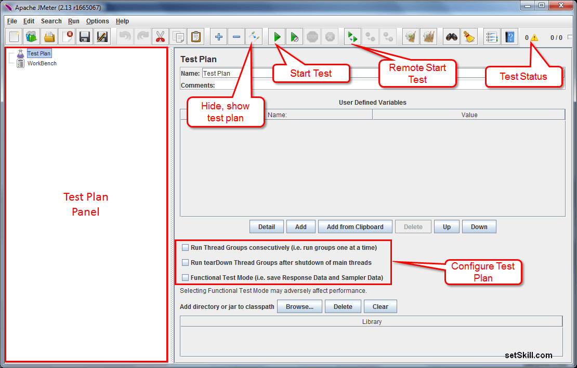
It double clicking on the ApacheJMeter.jar file does not work, you can also launch Jmeter by running the jmeter.bat file. This file is located under in the “bin” folder.
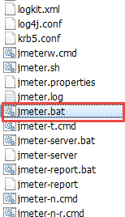

2. In Server mode
JMeter can not only run locally but also run remotely. You can execute the test via many other computers. Using this feature you can simulate a very large load on the server.
You can start JMeter in server mode by launching the file jmeter-server.bat in the windows command prompt. JMeter will launch as shown in the figure below.
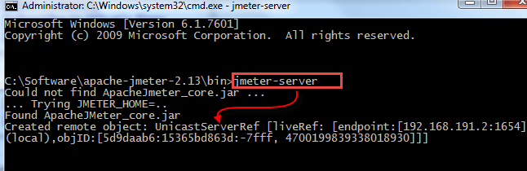

3. In Command line or non-GUI mode
Using JMeter in GUI mode is convenient for user but it consumes significant amount of memory. To overcome this problem, JMeter allows you to launch it in command line mode as well.
Many people use the GUI mode to create the load test plans and test it. Once they are sure the test plan is correct, they use the command line mode to execute the actual test. You can run JMeter in non-GUI mode by running the following command:
java -jar ApacheJMeter.jar -n -t mytestfilename.ext
The command line mode in JMeter accepts the following parameters:
- -n: Run JMeter in command line
- -t [Name of Test Plan file]
- -l [Name of log sample results]
- -r: Run the test in server mode
If you want to see the detailed options available in JMeter, you can use the command “jmeter –hIt will display a brief help text with all the options available in JMeter.
